Being a kid is just really hard for a number of reasons. I've generally thought it would be fun to go back to my childhood and frolic around the woods with no responsibilities and no life skills, but the more I think about it, being a kid was a continual stream of terrible situations.

First of all, you were incredibly uncoordinated as a kid. Simple games like catch were an exercise in futility.
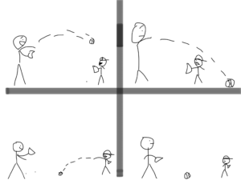
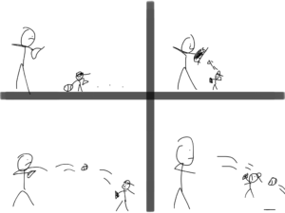

You were just stuck in this body that couldn't do anything correctly. Throwing and catching a ball was a continual exercise in failure. You weren't strong enough to throw it all the way to your target and you weren't coordinated enough to come even close to accidentally catching the return throw.
Being a kid and trying to accomplish anything was like walking around with numb hands while trying to thread a needle with flaccid yarn. Also, everything was confusing. Remember trying to figure out how to tie your shoes? You couldn't even read. It was a stressful time.

Haircuts were a particularly horrific experience as a kid.
My hair would finally get long enough to let me forget I was homeschooled when my mom would make me get it cut. In a bid to save money she'd have the barber, or closest available church lady, cut it as short as possible. This really brought to my attention just how far out my kid ears stuck.
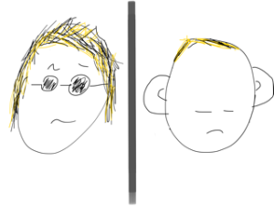
If you were lucky enough to have a comedian dad he'd probably say something like, "Looks like you got your ears lowered, huh?!" or "When did we get an elephant?" or "Wow! Look how big your ears are!" Those were the days.
Just kidding, my dad wouldn’t say most of those things.

Side note: As you can tell I've recently discovered I can doodle on my work iPad, so...
I was helpless in all facets of life as a child, especially the gathering of food. Without the direct support of my mom or dad, I'd have starved in a few hours. No idea how to fix anything in the kitchen. It was all one big mystery of random ingredients and magic.
As a kid you also had no idea how to be cool. I imagine if we could go back and listen to ourselves talk about anything as a 9-year-old we'd make it about 13 seconds before we cringed ourselves into oblivion.
I remember trying to wear my hat backwards for the first time and feeling particularly uncool when the leftover strap poked me in the eye. Having a tiny head while attempting to wear your hat backwards really drills into your brain the importance of remaining humble.

Farts were also a weird public embarrassment as a kid.
Up to about five years old you don't care at all about farting in public. For some reason old men also don't seem to care. It might be a hearing issue. I'm not sure. When you're a normal adult you care to a point, but it won't ruin your day if you accidentally let one slip.
When you're the right age of kid you're mortified when you accidentally fart in front of the class. The problem is you have no social skills that allow you to comeback from the situation. You're embarrassed and everyone knows you're embarrassed and the whole thing is just very upsetting. Here's a handy graph on how the shame of farts work with age.
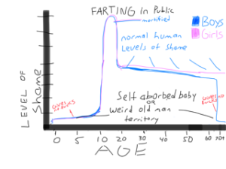
As a kid I was always embarrassed if I got caught farting. I'm not sure why. If I would have just owned it I would have been fine. I didn't have that life skill.
I still try not to let my wife notice when I fart. She doesn't say anything but I think she can tell. Some people just fart whenever the mood strikes. Particularly horrible couples actively fart on each other. I don't even like the word. I wouldn't have even put this section in, other than this was the first graph I've made for the blog and I wanted to incorporate it.
Accidentally letting one rip and having the entire class turn around and look at you is an especially harrowing experience. Couple that with the fact that as a kid you had no way of dealing with adversity and it's a recipe for disaster. Speaking of not having any skills...

You had zero survival skills as a kid
As a kid you had almost no instincts or ability that would translate into your survival. In fact, most of the things you did as a kid were in stark contrast to allowing you to survive any potentially dangerous situation.
If your mom walked around the corner at the grocery store she could be anywhere in the entire store within 5 seconds and anywhere on Earth within 30 seconds. Your tiny kid brain didn't tell you to go to the last place you saw her to see if she was there. Instead, you'd panic and were just as likely to turn and run the complete opposite direction looking for her. Can't find her in the first few seconds after running the opposite direction that you saw her? Better rush outside and see if she left. I have no idea how I survived to adulthood.

I almost got kidnapped one time...
...because a weird guy in a pickup truck offered me and my friends a ride "to the end of the parking lot" in the back of his truck. Yup. This is a true story. He offered to give us a ride to the end of the parking lot for no reason at all and that didn't raise a single red flag amongst our entire group.
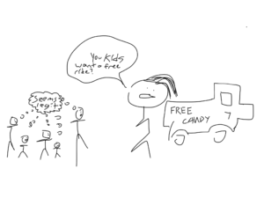
On a scale of 0-100 for survivability we cumulatively scored a 3 at best so we all jumped in the back of his truck. He could have just kept driving but luckily he took one look at our bowl cuts and decided he was better off actually dropping us off at the end of the parking lot. I guess looking like a bunch of homeschooled kids sponsored by the salvation army finally worked in our favor.
Kids will run out into the snow with no gloves on, shove their hands into actual frozen water, then look you dead in the eye with bewilderment that they can't feel anything from the elbow down.

Talking to girls almost never worked out well
One of the hardest things about growing up is becoming interested in girls several years before you have any redeemable qualities. Girls go from being icky to being friends to being these enigmas that you can't figure out but you kind of want to get close enough to smell. They continue being enigmas until about the age of 87, but you figure out ways to make it seem like you're not constantly lost around them.
As a kid, you have none of those coping mechanisms. One time a girl I liked wrote me a quick note and I responded by playing it cool and writing her a 6-page note letting her know (in a real round about way) that I was definitely not dating material.
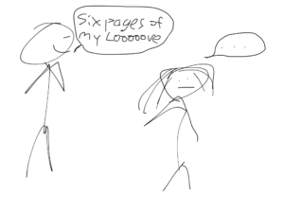

The night was terrifying
I slept on the couch for what seemed like months as a kid because literally everything scared me. It was a challenging time. As an adult I'm rarely scared at night. This is not the case when you're a kid. You're pretty sure monsters don't exist, but you can never be sure.
The night has many creeks and cracks, and as an adult you can pretty much rationalize or ignore them. As a kid every bump in the night is a creepy guy in a pickup truck who's come to murder you.

You had to spend a lot of time just waiting around
Sometimes parents just had shit to do and you were stuck tagging along. At least kids these days have iPads and iPhones to play with. We had an old germ-infested magazine to thumb through and maybe a toy from home if you planned ahead. Most of the time you were stuck just staring straight at the wall and pretending you weren't doing errands all day.
I don't think adults ever have to deal with the universe of boredom that comes from tagging along on errands. Even when we're bored as adults we at least can understand the time scale we have to deal with. As kids you didn't know if you were waiting for five more minutes or five more hours. It was the not knowing that really wore you down.

Projects were overwhelming
Think of how you break down any project you have to do. Need to clean the whole house? First you imagine dusting everything, then you imagine wiping down all the counters and finally you imagine vacuuming. As a kid you had no ability to set up a cohesive game plan.
Projects like cleaning your room seemed like impossibilities that you somehow eventually managed to get done through dumb luck and the shear calloused passage of time.
We lived on a 45-acre meadow. As a kid my dad told my brother and I we needed to pick up every fist sized rock in the entire meadow. Oddly enough he didn't distinguish our fist size from his. This was done so the horses wouldn't trip and hurt their ankles. He looked us dead in the eye and told us the project should take about five hours, if we really hustled. We picked rocks out of that blankity-blank field for the next decade until we both eventually went off to college. We never finished. Horse ankles beware.
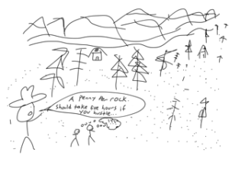
Related: A Penny Per Rock- The Original Side Hustle of Rock Picking
My point is, being a kid was hard. I have a lot of compassion when I see kids struggling because I see myself in them. Every ill-fated attempt to be cool, every uncoordinated trip, and every overwhelmed look of despair reminds me of me.
Reflecting on being a kid makes me really appreciate being an adult. Once you finish your time as a kid you've gone through roughly 80% of the upsetting life events you'll ever face. Maybe 90%. And, you had to do it all without alcohol. In my heart I know being a kid was fun. In my head, it was incredibly upsetting.
If you enjoyed this article, please share it with your friends and enemies
If you enjoyed this post you might also like:
The Burrito Bowl’s Go To Walmart- The Untold True Story
Why Small Talk is The Worst
“Hell Yeah, Give me the Off Road Tires,”- Mr. Burrito Bowl Almost Buys a Truck

