As humans we do a lot of things. We're always doing things, and some of them need to stop. Here's a quick list in case you were interested.

Putting Gluten-Free labels on things that have always been gluten-free
I'm a fan of things being labeled gluten-free if they traditionally have gluten. Pizza with no gluten? Slap a gluten-free label on there. Bag of apples? No. You do not get to put gluten-free on a bag of apples because you want to be trendy. It's like when diet water came out. In my research I found that we've successfully labeled water as gluten-free. Nice work, us.
Someone should come up with a diet gluten-free water.

Saying hello to acquaintances with anything other than a handshake
If we're not super close friends it means we don't have a secret handshake. Don't say hello to me and, instead of shaking my hand, do some kind of choreographed bro high five. I have no idea what to do next and it fills me with anxiety to the point of just wanting to stay home.
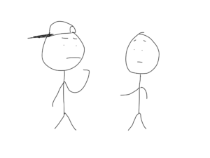
Don't finish our handshake with a fist bump, finger snap, slappy-slap or any other such thing. Shake my hand like a normal person.
If you want a hug instead of a handshake, I'm all for it. In fact, I prefer a hug if I have positive life feelings about your existence in general. Do me a favor and make your arms big and commit to it. Don't do a weird halfway handshake/halfway hug set up. I don't know what you want me to do and I'll panic.

Saying 'No Offense'
There is a 100% chance that immediately before or after saying 'no offense' something offensive was said. Nobody has ever said "no offense but..." then said something that wasn't kind of terrible.
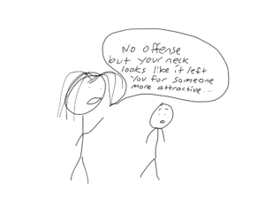
You can't just say 'no offense' and get a free pass to say whatever you want. If you want to tell someone you like them better when they aren't in the same room as you, just tell them. Don't start off with "No offense but...".

Giving kids participation trophies after the age of six
This is a dumb idea. When kids get participation trophies just for showing up, they never taste the crippling anxiety that comes from being soundly defeated. Dealing with the adversity of losing helps kids realize the world won't end when they lose.
When kids are basically babies who can walk (ages 1-5), I'm all for giving them participation trophies. None of them are actually playing anything correctly so it's really just a coin flip if you keep score.
In my first year of T-ball my best friend wore his mitt on the wrong hand for the entire season. He didn't make the connection and I never corrected him. Neither of us deserved a trophy.
Once kids start actually playing games and more or less following the rules it's time to stop with the participation trophies.
The un-athletic kids will eventually find out they are the un-athletic kids. It's much better to rip the band-aid off while they're still little and have time to learn math and science.
Learning how to lose graciously is a key part to growing up and becoming a functioning member of society. Getting participation trophies throughout childhood doesn't teach you how to lose with dignity, and it doesn't teach you if you want something you have to outwork everyone else to get it. Life doesn't hand out participation trophies- either you get the job or you don't.
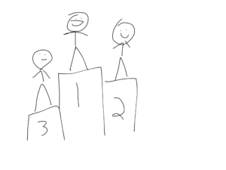
Regular Life with winners and losers- Third place is disappointed and wants to work harder, second place is pretty happy but wants to get better and first place is proud that he won.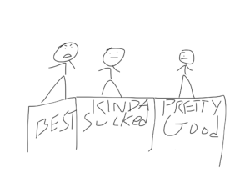
Participation trophy world where everyone is the same and nobody is proud of themselves- the best kid knows he got screwed, the kid who kinda sucked knows he didn't earn the recognition, and the guy who did pretty good just feels awkward about the whole thing.

Being offended about things that aren't offensive
There's too many people looking to be offended these days.
Also, being offended is not a good argument. If you want to argue something and your only footing is you're offended, then you're on shaky ground.
Also, are you really offended? I mean REALLY? Or do you just feel like you should be offended?
Let's agree to not be purposefully mean to each other, but also to not be offended if someone says something we disagree with.
People who are offended at everything probably got a lot of participation trophies as kids.
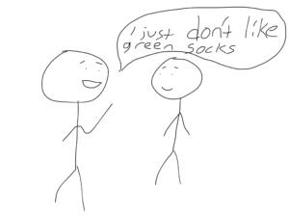

Driving slow in the fast lane
Listen, I understand that some of you enjoy getting to where you're going several minutes after you needed to get there. You people need to use the slow lane. The right lane is for people who obey laws, the left lane is for regular people.
If you enjoy driving 60mph on a highway where the speed limit is 60mph, then kindly move your slow rump over into the right lane so you don't make us all late.

Parking like an ass around handicap spots
Most non-handicapped people aren't big enough jerks to actually park IN a handicap spot, but a lot of people don't realize the lines next to the handicap spot actually serve a purpose. That extra margin is for people in a wheelchair to be able to exit their vehicle. Here's an actual picture of what I'm referring to since my stick figure drawing of this event would just be confusing.
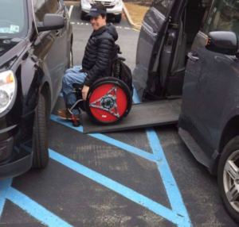

Being on our phones in restaurants
Reading this article notwithstanding, people should make an effort to be on their phones less. This is especially true in restaurants. Nothing makes me want to steal entire entrees off people's plates more than seeing a group eating together and none of them are making eye contact with anyone else at the table.
They're all just on Instagram posting pictures of their amazing dinner with their besties. Then they're all 'liking' each other’s pictures commenting stuff like "omg best night ever!" or "Hilarious laughing emoji face" while their actual face remains bored and unmoved.
I really want to sit down at tables like this and see how long it takes before anyone notices I'm there.
If you're out in public with another human be respectful and put your phone away.
Along those lines...

Taking pictures of food
Just stop. Nobody cares that you ordered a hamburger with pickles. Now, if you MADE something that looks exceptionally good, just go right ahead and take a picture. If you ORDERED something that looks exceptionally good, just shut up and eat it. Everyone knows you're only taking a picture of it to brag to your social circle that you live the type of life where fancy hamburgers with pickles are ordered. It's a bit much.
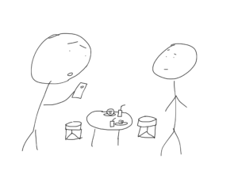

Putting People on Speaker Phone When Other People are Around
This one is either mildly annoying or just disrespectful depending on which side of the phone you're on. If you're in a room where someone is talking on speaker mode, then it's annoying to have to listen to a conversation you have no interest in.
If you're the person who is unwittingly on speaker phone, it's disrespectful if the person you're talking to doesn't tell you you're on speaker phone.
You might think you're talking to someone in confidence when you disclose the rash on your nether regions, but really a whole house of people just heard you. It's a bit disrespectful.
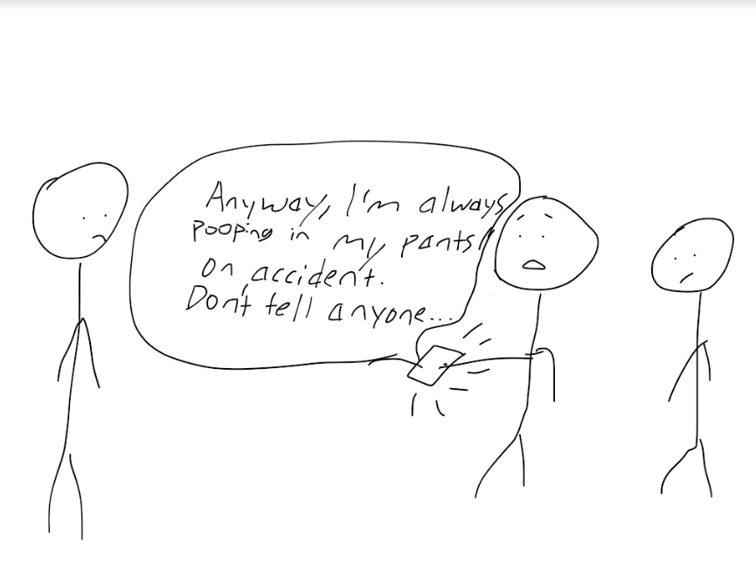

Owning Microfiber Sheets
These are just awful.

Vegetarian Eggs
Chickens are not vegetarians. What kind of farmer feeds his chickens celery and carrots? This is not how life works. Chickens are omnivores not herbivores. While we're at it...

Making Vegan Cats Out of Regular Cats
Cats are carnivores they are not vegans. If you want to be a vegan, more power to you. May I suggest owning a rabbit? If you own a cat and feed it only vegetarian/vegan cat food, then you're slowly starving your cat and it's probably going to die young because you're a terrible owner.
Your cat is just biding its time waiting for you to die so it can eat your face and finally get some iron.

Dying Eggs Brown
Back to eggs- eggs aren't all uniform in color. The egg people think we're stupid, so they dye the expensive eggs a weird brown monotone that somehow makes us think they're more natural because brown is a more natural egg color than white.
Thank you for reading my short list of things we should stop doing. If you enjoyed this article you might also like:
Being a Kid was Harder Than We Remember (With Illustrations)
January Recap- Pooping, Crying, and The Baby Did Stuff Too
Forever Will Happen and Why It’s Incredibly Upsetting
Feel free to share this with friends and enemies and add your own things we should stop doing in the comments!

